**Linux VIM Exercises**

03/22/2024

John Bradley Webb IV

Exercise 1: Opening a File in Vim

* Successfully navigated to the directory containing the file.
* Used Vim to open the file example.txt.

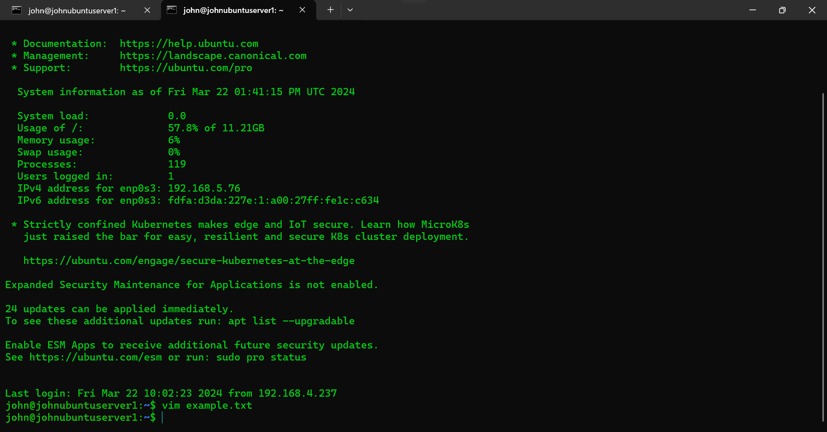

* Easily navigated through the file using the arrow keys.
* Exited Vim without saving changes by typing :q! and pressing Enter.

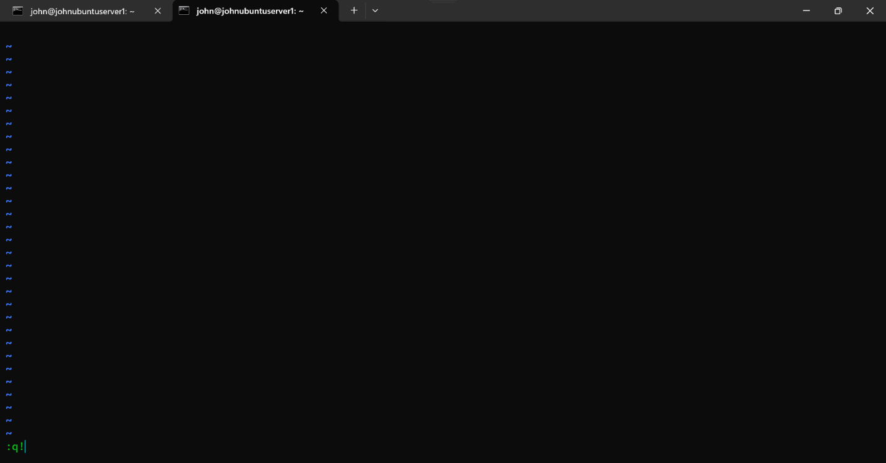

Exercise 2: Editing and Saving Changes

* Opened document.txt in Vim.

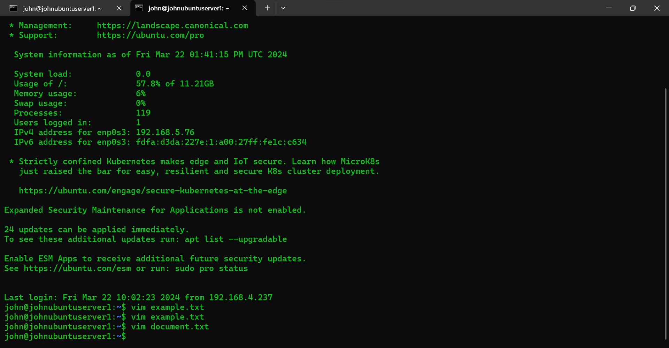

* Entered insert mode and added the line "This is a new line of text" to the end of the file.

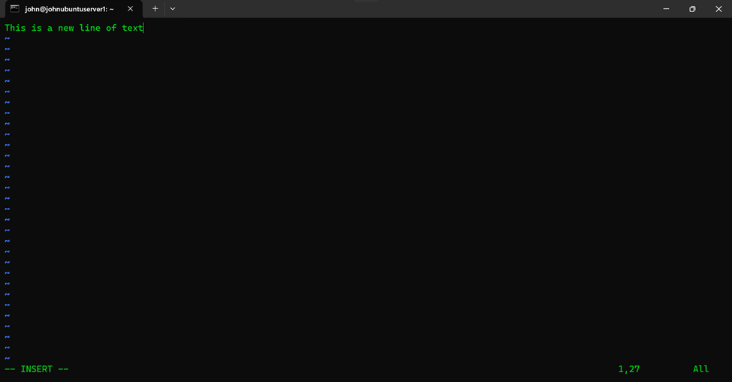

* Saved the changes and exited Vim by pressing Esc to leave insert mode, typing :wq, and pressing Enter.

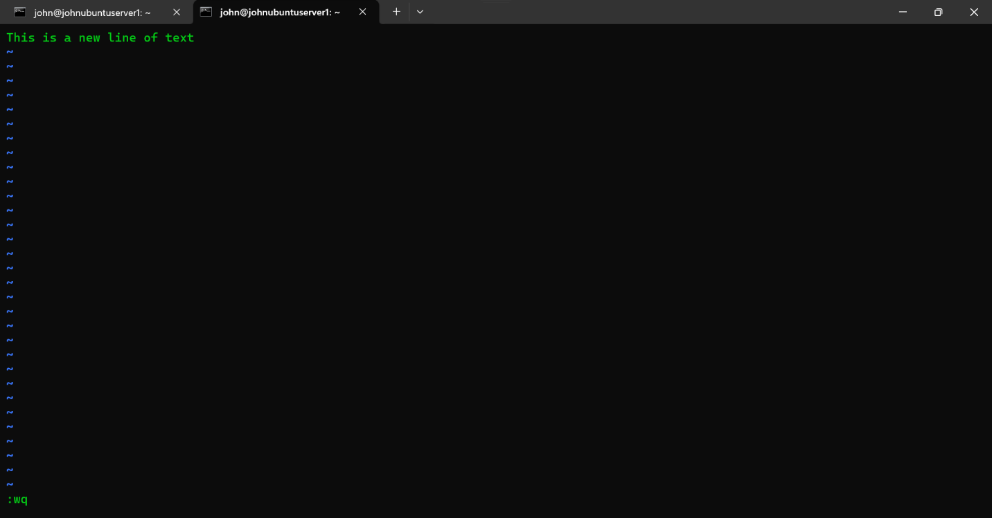

Exercise 3: Searching for Text within a File

* Opened report.txt in Vim.

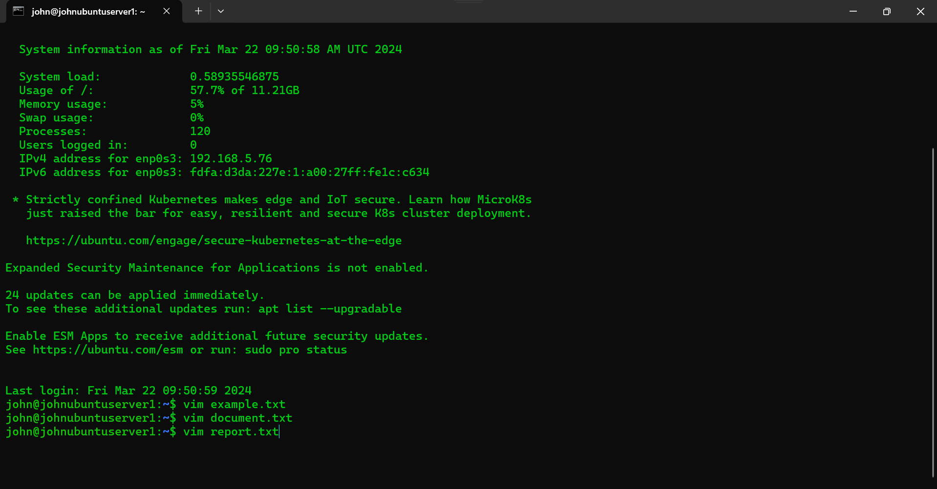

* Searched for the word "summary" by typing :/summary and pressing Enter.

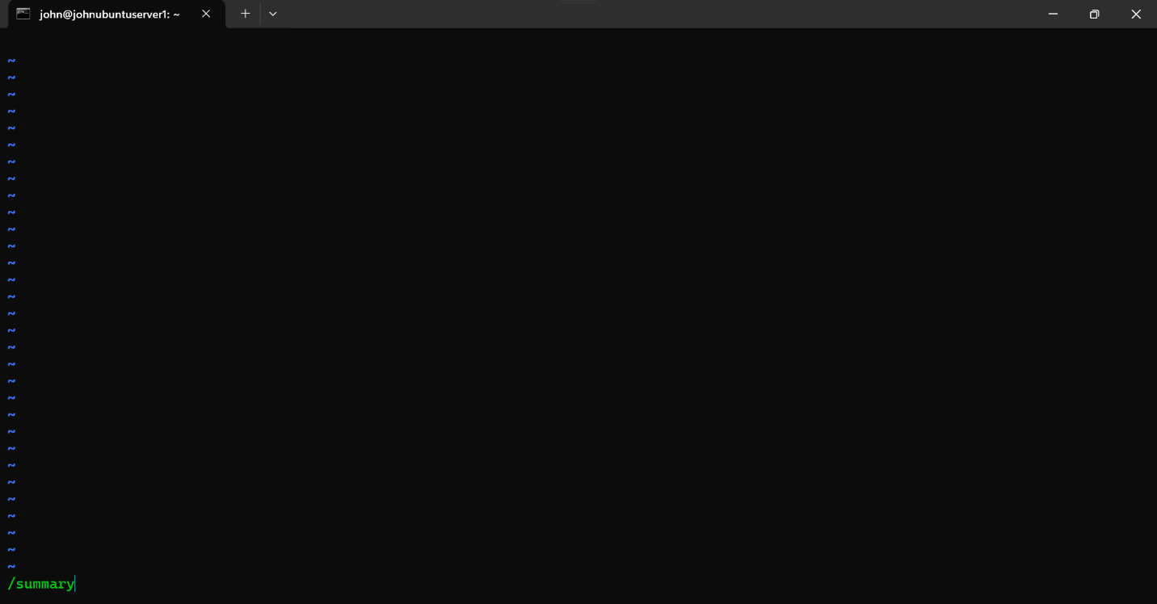

* Navigated to the first occurrence using n and entered N to move to the previous
* Successfully exited Vim by typing :q! and pressing Enter.

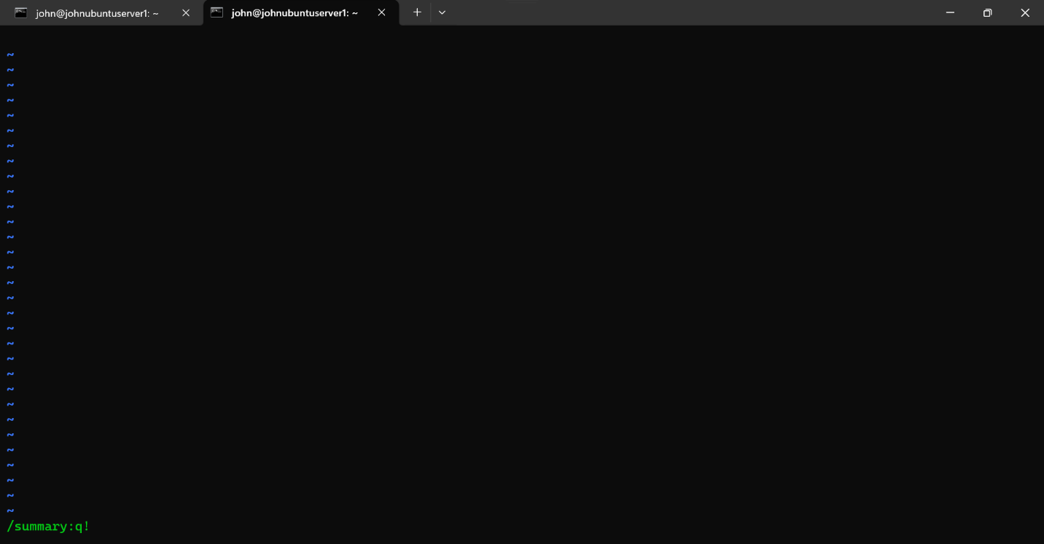

Exercise 4: Downloading and Opening a File from the Gutenberg Project

**Objective:** Download, and then open an existing file named pg25973.txt in the current directory using Vim.

* Successfully downloaded the file pg25973.txt from the Gutenberg Project using the wget command.
* Validated that the file pg25973.txt was present in the working directory.

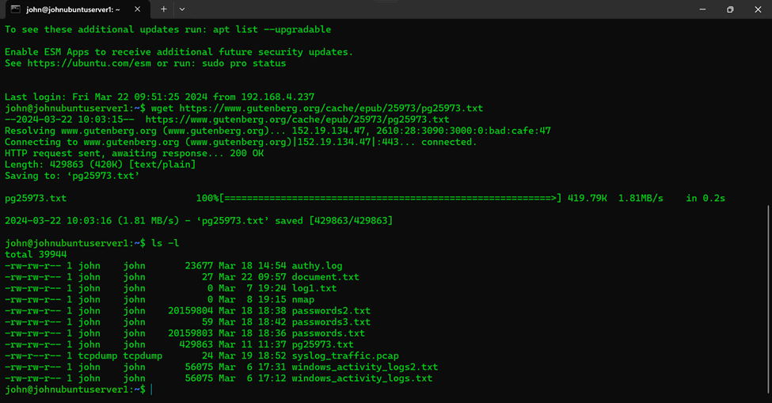

* Used Vim to open the file pg25973.txt.

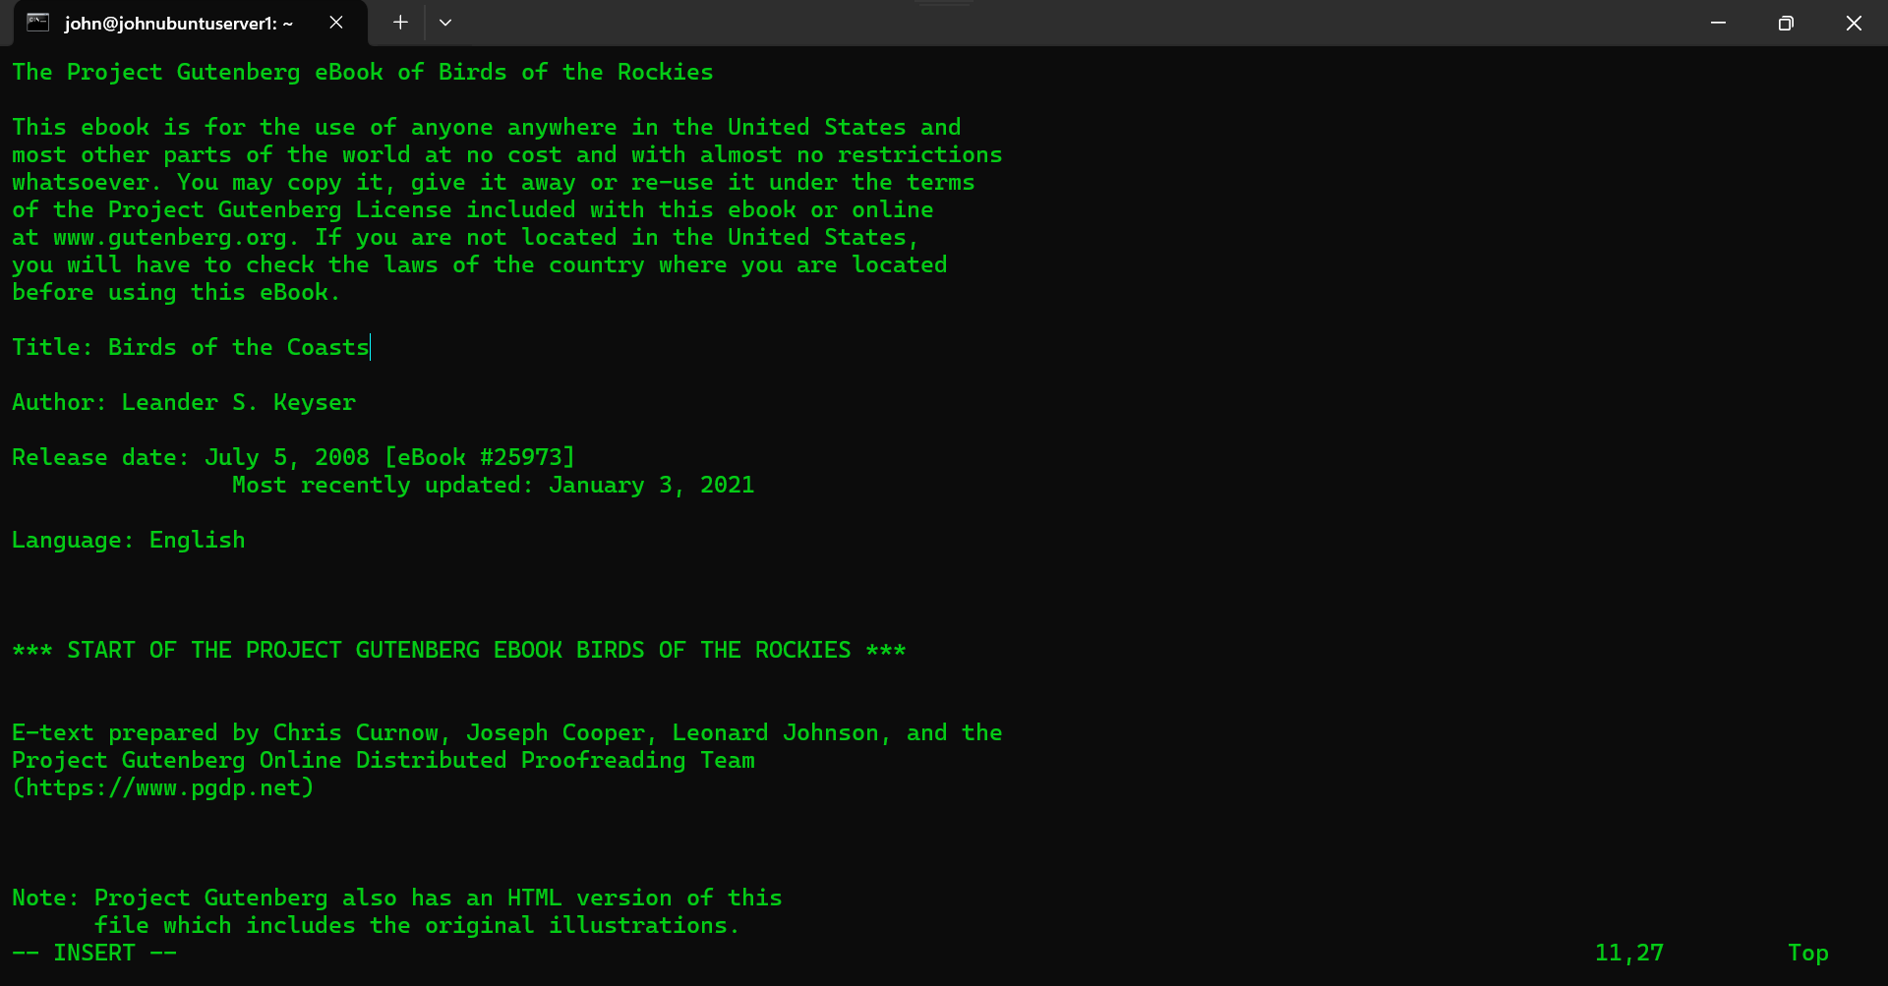

* Navigated through the file using the arrow keys.
* Exited Vim without making changes by pressing :q! and then Enter.

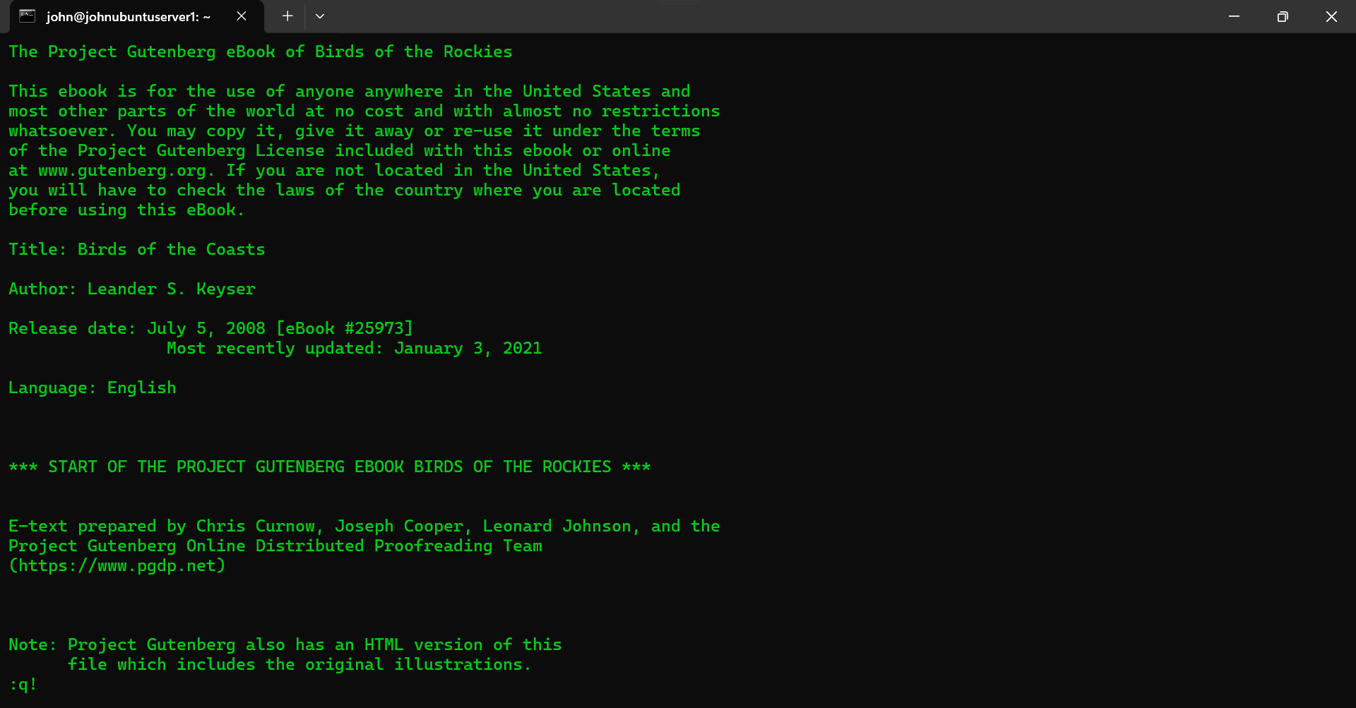

Exercise 5: Editing a File from the Gutenberg Project

**Objective:** Open and edit an existing file named pg25973.txt in the current directory using Vim.

* Successfully opened and navigated through the file pg25973.txt using Vim.

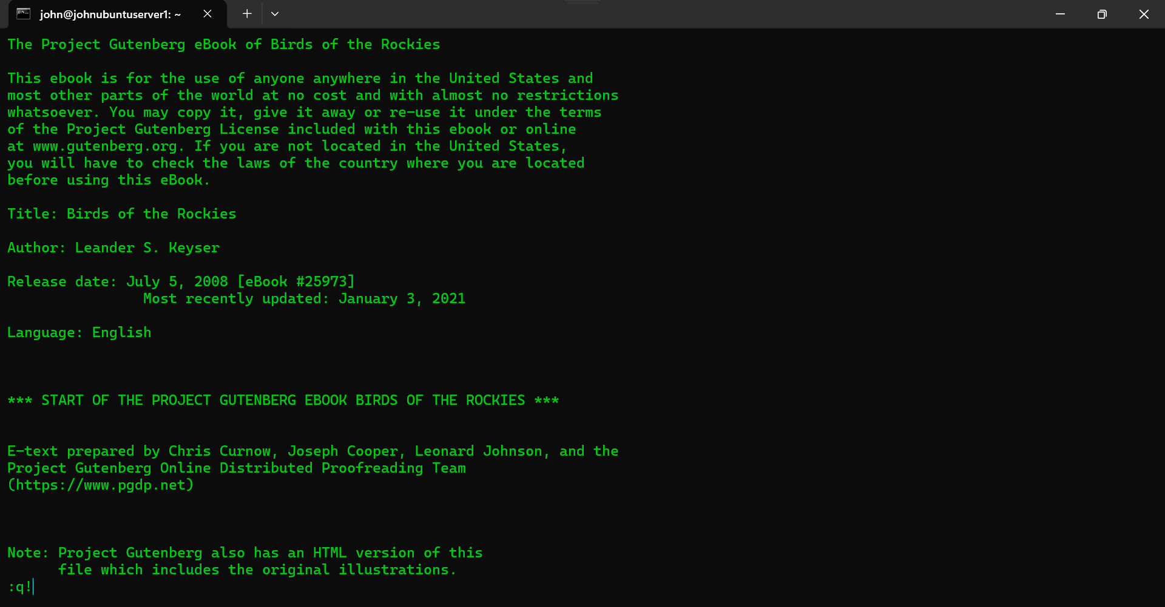

* Located the section stating "Title: Birds of the Rockies".
* Switched to INSERT MODE and modified "Title: Birds of the Rockies" to "Title: Birds of the Coasts".
* Exited Vim without saving changes by pressing :q! and Enter.

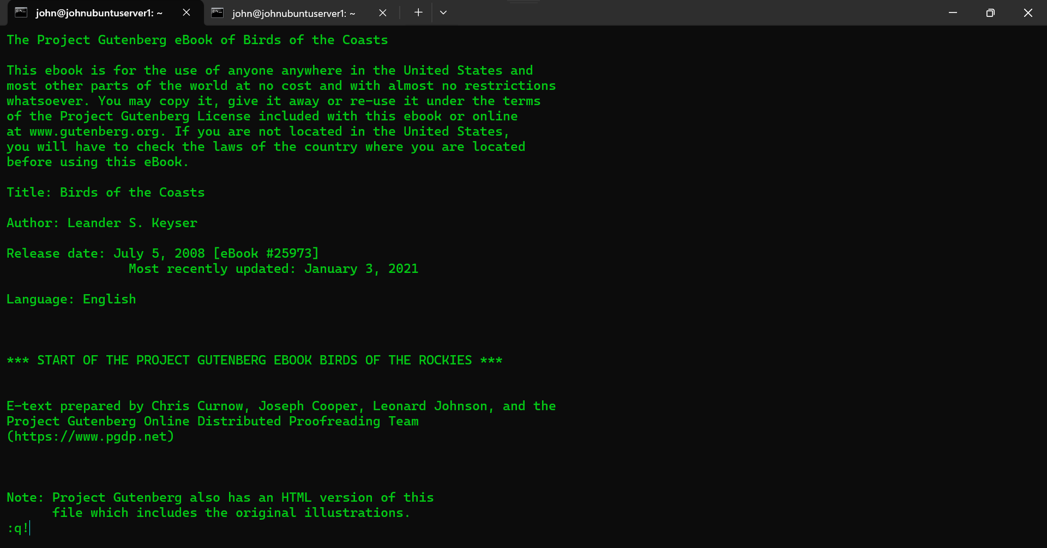

* Reopened the file pg25973.txt in Vim and navigated to the section "Title: Birds of the Rockies".
* Confirmed that exiting without saving changes abandoned the modifications.

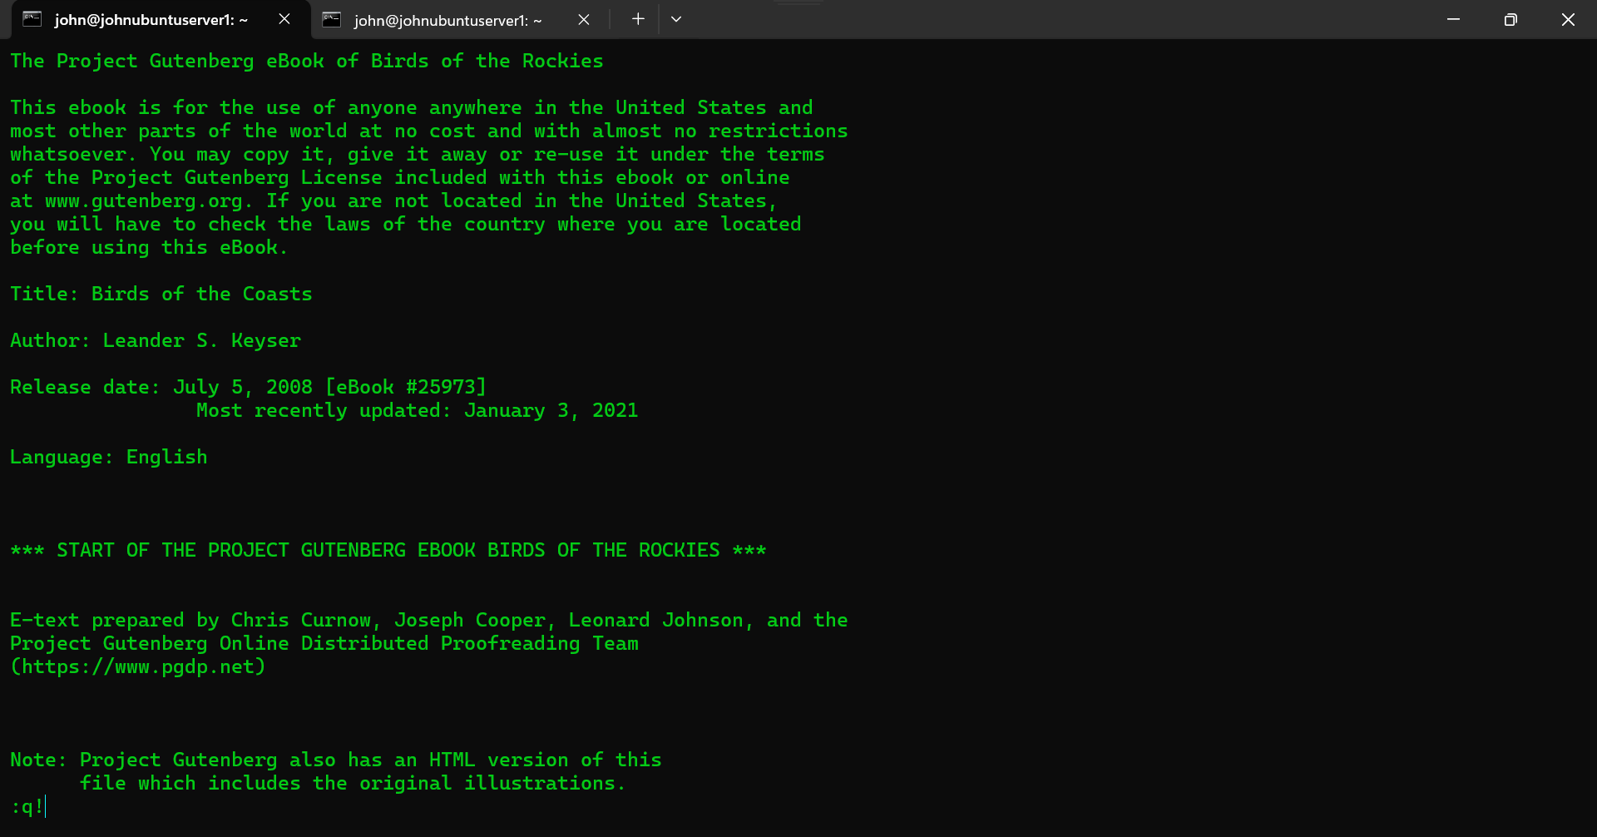

* Modified "Title: Birds of the Rockies" to "Title: Birds of the Coasts" and exited INSERT MODE.
* Saved changes in COMMAND MODE by typing :w.
* Exited Vim by typing :q in COMMAND MODE.

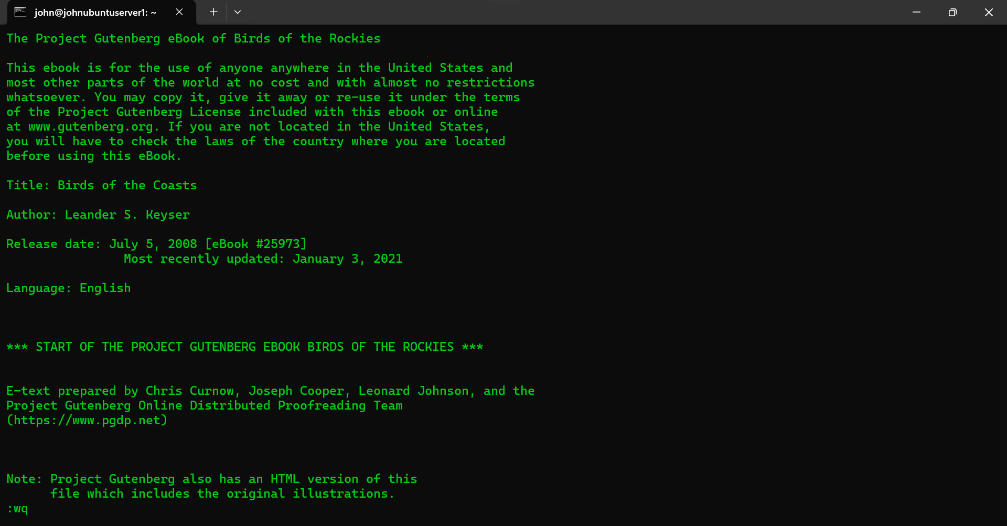

* Validated changes using the head -n 15 pg25973.txt command.

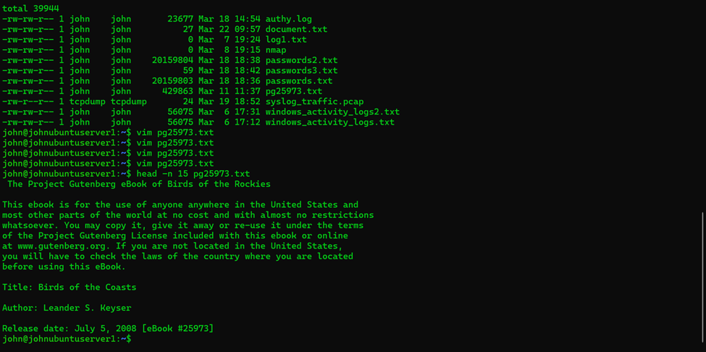

Exercise 6: Downloading and Opening a File from the Gutenberg Project v2

**Objective:** Download, and then open an existing file named pg100.txt in the current directory using Vim. This is the “Complete Works of William Shakespeare”

* Successfully downloaded the file pg100.txt, which contains the Complete Works of William Shakespeare.

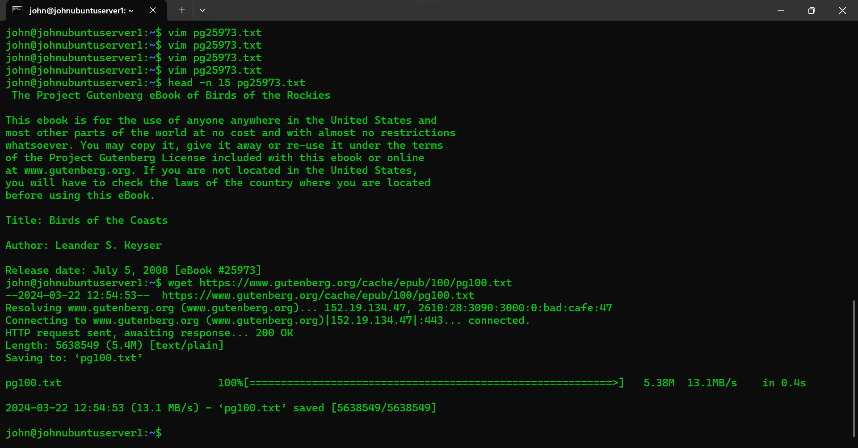

* Opened pg100.txt in vim, edited it, and then abandoned the changes.

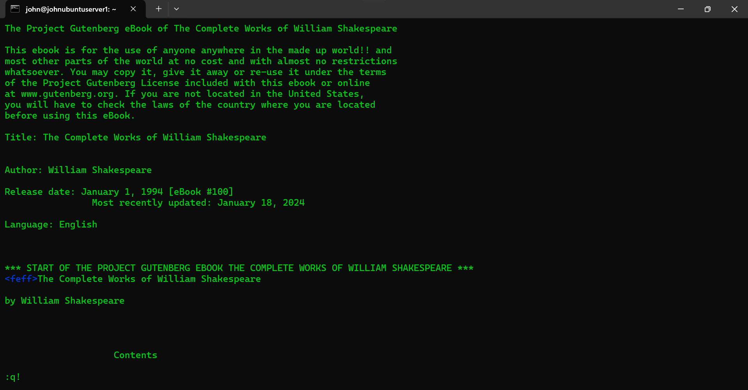

* Confirmed that the changes didn't get saved.
* Opened pg100.txt in vim again, edited it, and saved the changes.

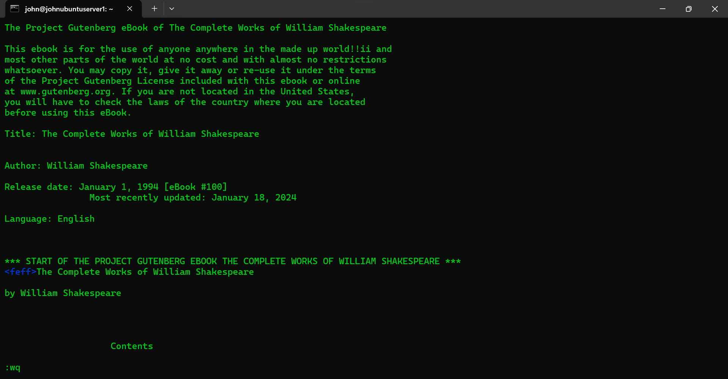

* Confirmed that the changes did get saved.

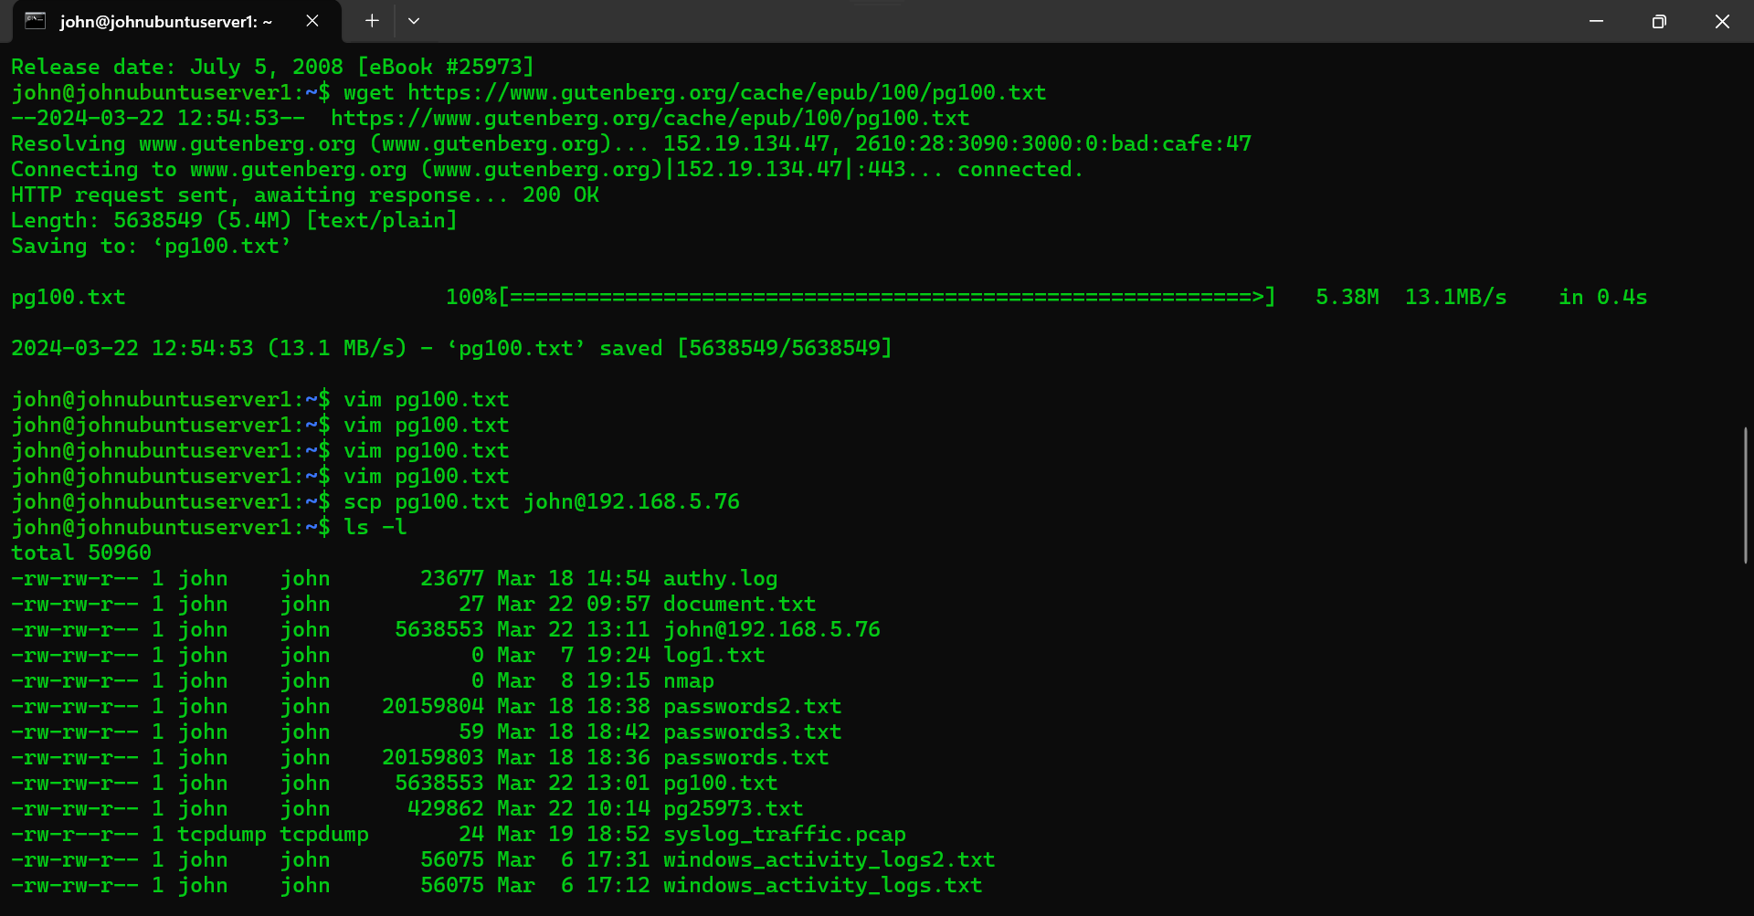

Top of Form

Exercise 7: Downloading and Copying a File from the Gutenberg Project to Linux

* Successfully downloaded pg100.txt in Windows.

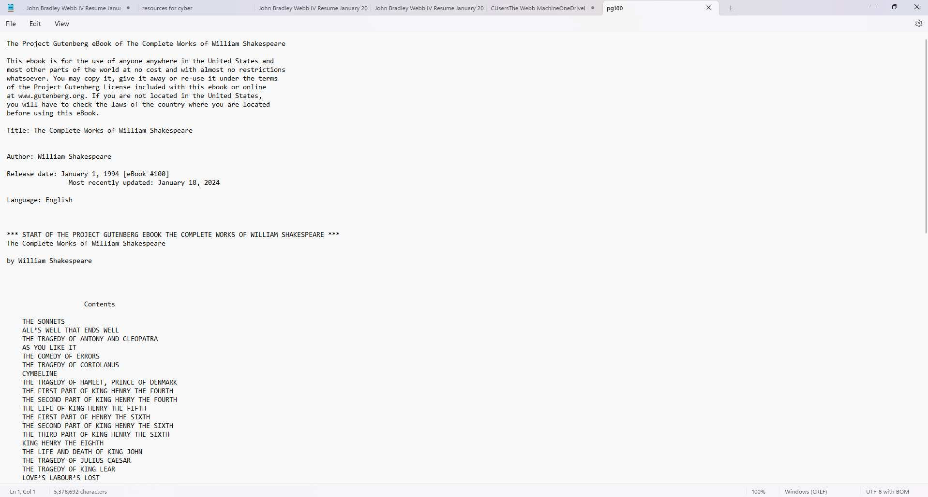

* Copied the file to the Linux server using scp.

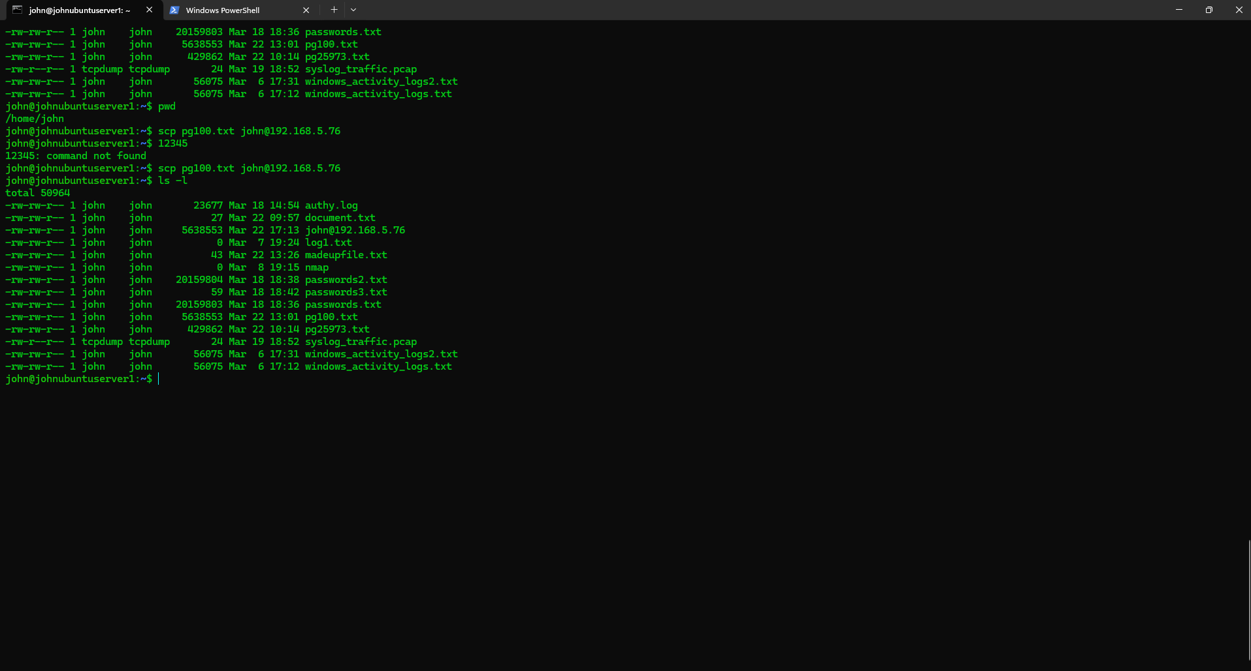

Exercise 8: Creating a Text File “madeupfile.txt” and copying it to Windows

* Created a text file via vim.

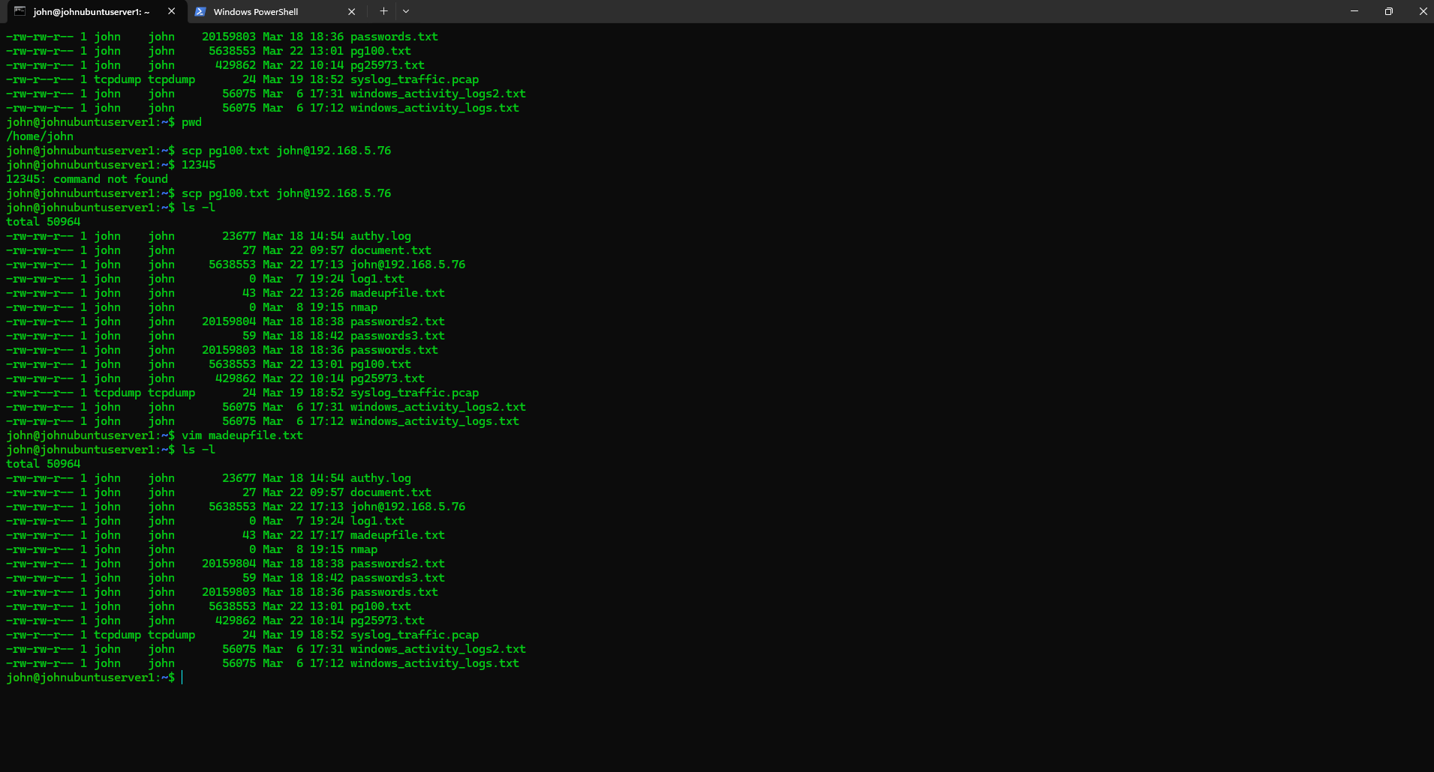

* Copied the file to the Windows workstation using scp.

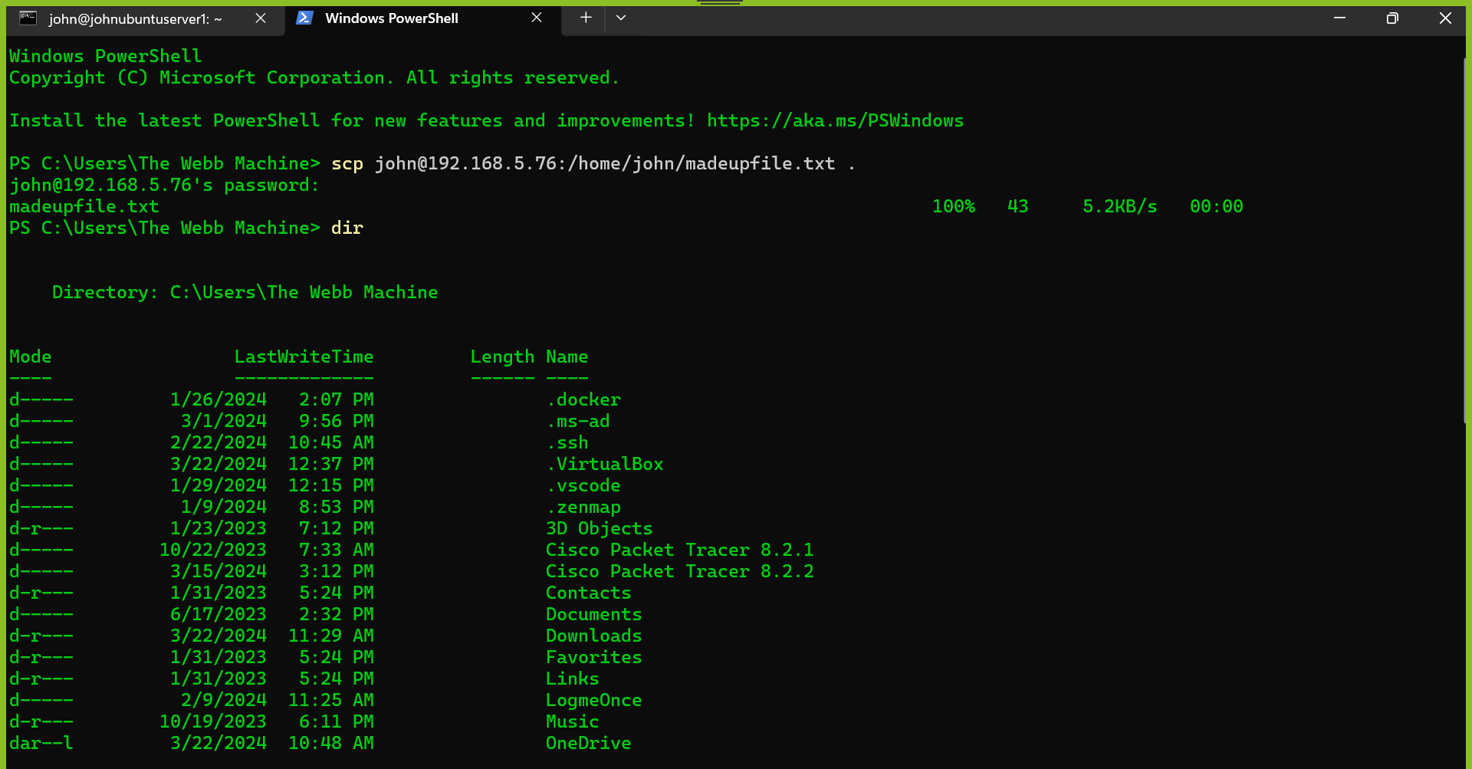

Exercise 9: Creating a Text File and Copying it to Windows

* Ensured there were 3 or more text files in the Linux home folder.
* Copied the files to the Windows workstation using scp with a single command.

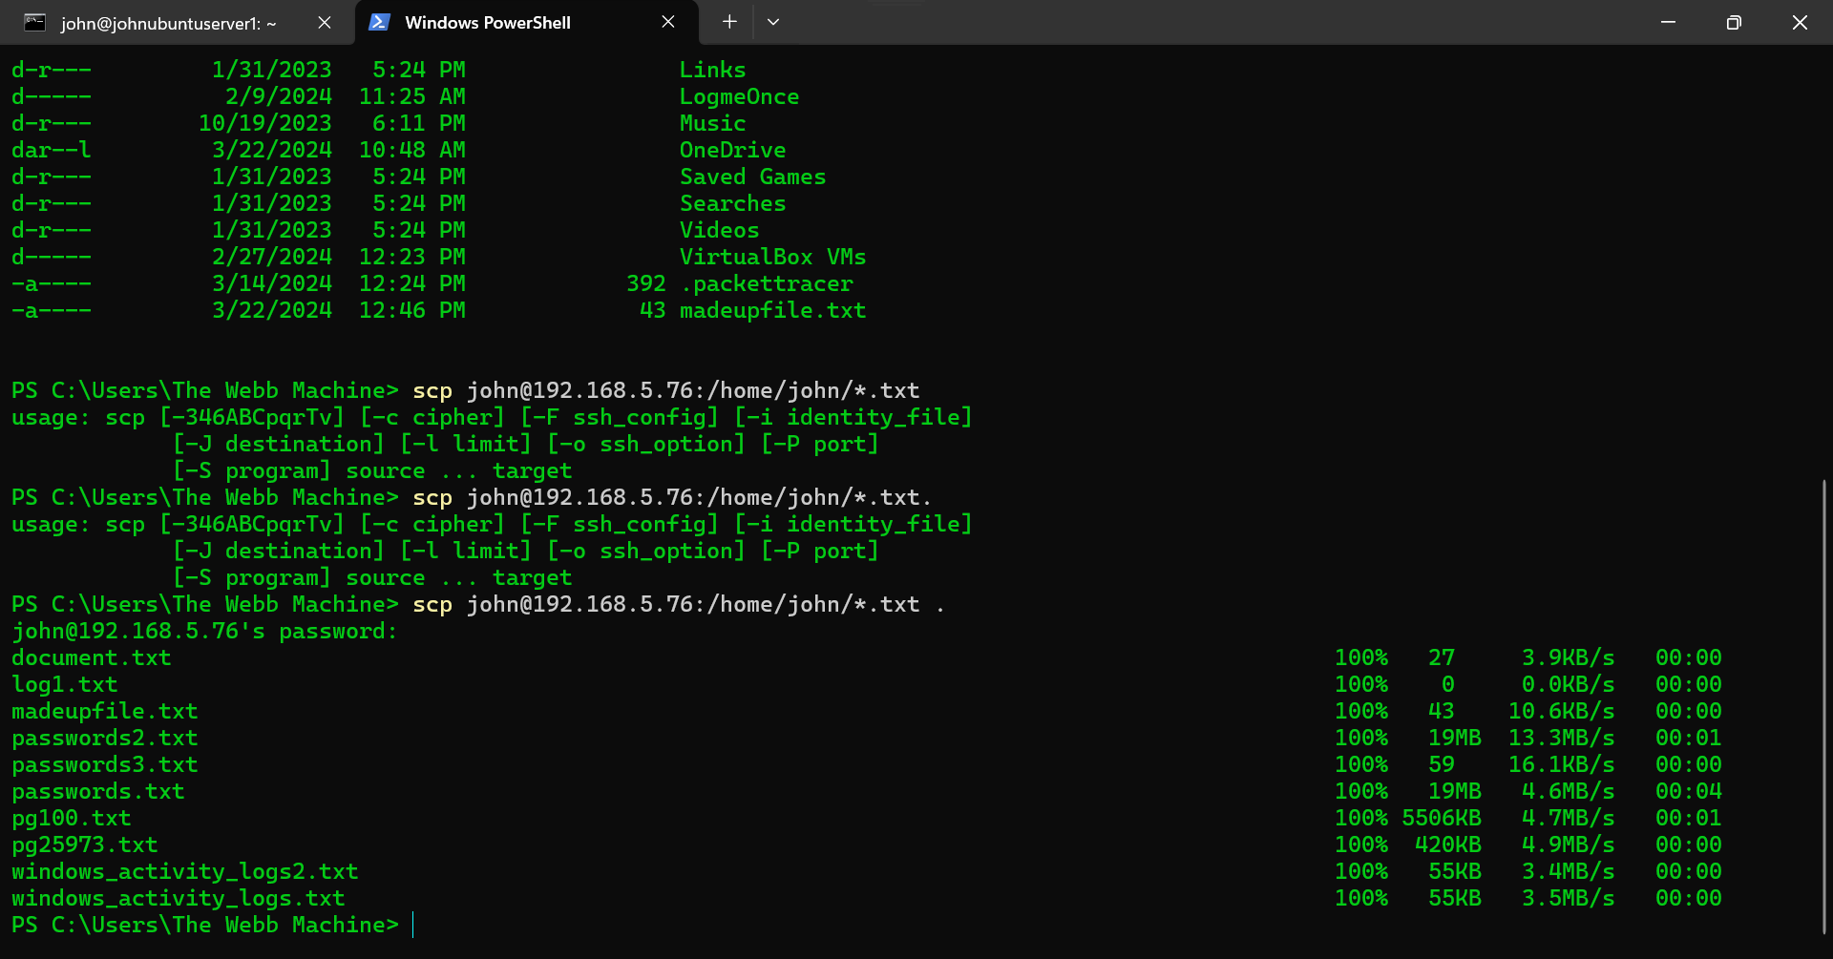

Top of Form

Exercise Assignment reflection:

Mastering Vim in the context of Linux is not merely advantageous but fundamental for cybersecurity practitioners. Vim's lightweight nature, ubiquitous presence across Linux distributions, and powerful text-editing capabilities make it an indispensable tool in the cybersecurity toolkit. In a field where quick and efficient analysis of log files, scripts, and configuration files is paramount, Vim's advanced functionalities and keyboard shortcuts facilitate rapid navigation and manipulation of text-based data. Furthermore, its extensibility through plugins and integrations allows for seamless collaboration with other cybersecurity tools and workflows, enhancing overall operational efficiency. By becoming proficient in Vim, cybersecurity professionals can significantly streamline their workflows, optimize data analysis processes, and ultimately fortify defenses against cyber threats in the dynamic and ever-evolving landscape of cybersecurity.